# LESSON LEARNED REPORT

## 10.3 Communications Management **[Ang Chee Siah, TP038259]**

**INTRODUCTION**

In an undergoing project, communications management is a vital element to ensure that information is effectively delivered to and received from every departments of the project team. This element of project management includes roles in managing effective meetings between teams, forming an efficient communication means for all departments, applying appropriate technology usages for ease of interaction, and providing sufficient templates for formal communication methods. In general, there are 3 processes involved in a project’s communications management: **planning**, **managing**, and **controlling**.

**ISSUES INVOLVED**

|  |  |  |  |
| --- | --- | --- | --- |
| **Communication Management** | | | |
| **Issue No.** | **Issues** | **Project Management Process** | **Tools & Technique** |
| 1 | The steering committee (which consist of the board of directors, CEO and Senior Managers of the organization) do not recall of being presented the project feasibility study by the Project Sponsor or the Project Manager to them. | Initiation | **Communication Requirements Analysis**:  Determine all stakeholders’ means of communications, calling intervals and recommended timing plus the duration |
| 6 | There was redundancy of work performed as the Work Breakdown Structure (WBS) was done separately by each respective department and the Project Manager did not review and then consolidate those WBSs into one wholistic WBS | Initiation; Planning | **Meetings**:  Gathers the stakeholders for a face-to-face deliverance on the working requirements for a complete, centralized WBS  **Issue Logs**:  Identify all issues that the project has and delegate manpower easier based on the problem-solving strategies’ comparison |
| 7 | Most of the team members have been focusing more on their daily operation support rather than tasks being assigned by the Project Manager or their respective Team Lead | Execution | **Performance Reporting**:  Conduct a daily-to-monthly check routine to ensure the project plan is being followed and ensure the team members are doing their task as provided. |

**PLAN COMMUNICATIONS MANAGEMENT**

In this stage, all **stakeholder’s needs** on information and communications are **identified**. An appropriate **communication approach** would be decided based on those communication needs and requirements.

While it is necessary to have a project management plan, registers of stakeholders, enterprise environmental factors and organizational process assets to start on a plan communications management, this process could create a **communications management plan**, along with an **updated project document**.

**Communication Requirements Analysis**

Firstly, the stakeholders’ needs in the project’s communication channels must be understood via **data collection and analysis**. Each stakeholder would be inquired of the **preferred communication** **means** individually or collectively, which would then form a suitable planning template for all stakeholders, normally by plurality.

However, the analysis could form either a generic template or event-specific templates according to the level and frequency for the stakeholders needed to communicate among the project team (España, et al., 2009). In this case, a generic template would be produced as the project team has less need of frequent contact with outside parties relative to a typical project that requires event-specific templates. It also meets the needs of the waterfall model management method to have a central communication system that creates less confusion and more focus.

To solve **ISSUE NO. 1** via this method, a meeting – by gathering or personal visit – among the steering committee is required to **obtain information on all their frequent means of communication** via *Communication Requirements Analysis* and devise the best means of information deliverance that **can reach everyone in shortest time possible**. Although straightforward and simple, this solution is necessary to **prevent “hit-and-miss” scenarios** in informing the important project members, Board of Directors included, by determining a universal communication means. In case of “hit-and-miss” via the universal channel, the alternative contact details via the collection and analysis could be used immediately to prevent further delay.

**Communication Roles and Responsibilities**

While all stakeholders’ requirements on communication needs are needed to be identified, the communication plan should be made based on their **priority** on their **roles and** **responsibilities** as well. Based on the priority level, the planning template for communications could be more organized to **prevent disturbances** such as ‘role blurring’, a risk that involved staffs within a project team consistently unsure about their responsibilities (Esther, et al., 2009).

**Communication Management Plan Template**

A plan template is vital to create a communications plan in order to **understand all available options** of interaction within the project team, in the **quickest and clearest manner** possible. In this case, a template in a form of **generic table** is proposed, including sample inputs as reference in ***TABLE 10.3.1***:

|  |  |  |  |  |
| --- | --- | --- | --- | --- |
| **STAKEHOLDER NAME** | **ROLE(S)** | **DOCUMENT**  **(NAME & FORMAT)** | **AVAILABLE IN (PLATFORM)** | **CONTACT BY (DEADLINE)** |
| Monos Krome | Quality Control | Progress Report  (Printed Copy) | Face-to-Face;  WeChat | Each week, Thursday |
| Lunaire Mun | UI (User Interface) Designer | User Interface Design Draft (.ai Format & Printed Copy) | E-mail;  Face-to-Face | 24/7/2018 |
| Apolloa Sun | Software Engineer | Status Report  (E-mail) | Discord;  E-mail; LINE | Each week,  Monday |

***TABLE 10.3.1: Communication Management Plan Template for ISCMP***

**Communication Technology**

In terms of communication technology in a project, it could be generally divided into 2 main channels: one that requires document transfer, and one that is meant for personal chats and talks only, as proposed by the sample data collection on Morey’s article (Morey, et al., 2013).

While in terms of communication, **document-transfer-based** channels are mostly used by the staffs on the development-based team such as Software Engineers and UI Designers in this scenario. Services such as *SourceTree* and *GitHub* proves a suitable medium for inter-changing software progress and codes to ease the process of creating certain features in the same program.

Channels that are more **chat-based** from *WhatsApp* and *Skype* would prove a more decent approach for in-depth discussions on concepts, proposals and feedbacks among the management teams, where Project Managers would frequently use to contact development teams and board of directors to update on the project’s progress and deliver opinions.

**Communication Models**

Communication model is a representation on how communication, in general, works using senders and receivers as the each ends of the model, with the communication channel itself acting as the medium connecting them together along with several elements as well, such as the reference diagram in ***FIGURE 10.3.1***.

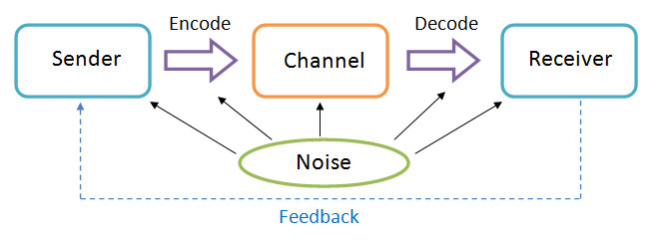

***FIGURE 10.3.1: Basic Communication Model based on Shannon-Weaver Model***

Communication model is a concept that would be applicable when devising a universal communication channel to everyone in the project, as it allows the **anticipation on how the message is transferred** (McQuail & Windahl, 2015) via the following elements:

1. **Sender**: How many people would be sending the information via this channel?
2. **Receiver**: How many people would receive the information, and in which format?
3. **Encode**: Would the message encodes into the information the way sender wants?
4. **Decode**: Would the information decodes into message the way the receiver wants?
5. **Noise**: What interference would occur when using the channel, and how big is the impact?

Using a comparison between 2 communication means, *Face-to-Face* and ­*E-mail* for a scenario where the UI Designer would submit a design draft to the Project Manager in a 1-time basis*­*, a comparison could be made between these two methods in ***TABLE 10.3.2***:

|  |  |  |
| --- | --- | --- |
| **Face-to-Face** | **Communication Elements** | **E-mail** |
| UI Designer (in person) +  Design Draft Documents | Sender | UI Designer’s E-mail Account |
| Project Manager (in person) | Receiver | Project Manager’s E-mail Account |
| Verbal input from UI Designer + Display of Design Draft Documents | Encode | Word input from UI Designer +  Digital Copy of Design Draft Documents available for view |
| Project Manager listens in real time  (verbally sends feedback when needed) | Decode | Project Manager views E-mail when he is free  (reply via E-mail when needed) |
| * Venue acceptable by both sides * Surrounding sound (if the venue is too loud) | Noise | * Different interpretation of words and terms in E-mails * Requirement of internet service |

***TABLE 10.3.2: Face-to-Face and E-mail Comparison using Shannon-Weaver Model***

Based on the comparison, Face-to-Face method relies more in **verbal exchange** between senders and receivers while E-mail method relies more on the exchange of information via E-mail accounts that mainly uses **written words** in displays. In contrast, the usage of Face-to-Face method requires interaction **on-the-spot** for both sender’s and receiver’s sides while E-mail method **requires devices** **that contains their respective E-mail accounts** regardless of the location.

While the respective encode and decode methods are unique at their own way, the noise factor determines that Face-to-Face would be a better option for as this method **only has downside in terms of venue of selection**; while E-mail methods require use of internet service and **information deliverance might not be as effective**, especially the meeting is for 1-time only.

Therefore, it is recommended for the use of **Face-to-Face method** for the meetings, while E-mail method could be used as an alternative for more frequent meetings in the future.

**Communication Method**

Besides using communication models, determining the suitable communication method is equally important in anticipation of suitable communication methods. There are 3 types of communication methods that could be classified as **Push**, **Pull**, and **Interactive** methods (Lewis, et al., 2009).

***Push*** method is where the sender of information would communicate with the receivers, but usually in a **one-way** basis where the sender determines the receivers, when and how they receive it. Although **immediate and direct**, such method **limits interactivity and feedback from receivers** to nearly zero. In this instance, it could be classified along with **broadcasts and announcements** by the Project Manager to the Software Engineers of the management team on the ISCMP’s scope and requirements.

***Pull*** method, on the other hand, is where the receiver of the information could obtain information from a medium on **self-service** basis. The senders would store information in that medium and all receivers could access the information from there. This method is **convenient for informational relays**, but **not time-sensitive** as the information is accessible at any time, renders the urgent messages inapplicable via this method. Instances that are adaptable to this channel is by using **self-service sharing platforms** such as SourceTree to obtain latest updates on the software progress would be convenient for the Software Engineers.

***Interactive*** method allows **cross-interaction** between senders and receivers, usually in text, or graphics and sound. **Discussion would be allowed** from this method as both sides would obtain and deliver information on first-hand basis. While the **most convenient and traditional** way, interactive method is not recommended to have too frequently in this project as it might be **time-consuming** and in specific instances, easily sidetracked based on the target of conversation. However, it is still a mandatory method to use in developing of ISCMP when a meeting is held among the board of directors to conduct Status Report for the software’s progress in regular basis.

**Communication Matrix**

Communication matrix is applied as a list for the required to relay the priority and frequency of the required deliveries, communication-wise. A template in the form of table would be created to simplify the information for the project management’s reference in ***TABLE 10.3.3***:

|  |  |  |  |  |
| --- | --- | --- | --- | --- |
| **COMMUNICATION** | **PURPOSE** | **FREQUENCY** | **DURATION** | **AUDIENCE(S)** |
| General Information | Introduce project, scopes and objectives | One-time Only | 2 Hours | * Project Team * Project Sponsor * Stakeholders |
| Interface Design Meetings | Review and discuss software design problems and solutions | As needed | 3 Hours | * Project Team * UI Designers * Project Manager |
| Status Update | Detailed report on project progress, costs, and issues | Monthly | 1 Hour | * Project Team * Software Engineers * Project Manager |

***TABLE 10.3.3: ISCMP Sample Communication Matrix***

**MANAGE COMMUNICATIONS**

Based on the communications plan created from the planning stage, the managing stage would focus on **creating and distributing the proposed communication means** to the desired project teams.

Using the already devised communication management plan along with required work performance reports, enterprise environmental factors, organizational factors and organizational process assets, a proper **project communication** would be formed. Along with that, **updates** on the **project management plan**, **project documents**, and the **organizational process assets** would be delivered in regular intervals to monitor how smooth or rough the communication within the project would proceed.

**Performance Reporting**

Performance reporting is a means for stakeholders to **be informed on the project’s progress** and how much of the project objectives have been met at specific intervals (Tooley, et al., 2010).

To solve **ISSUE NO. 7** where the development staffs do not adhere to the tasks based on the respective priority of the job, the need of performance reporting would be vital to ensure all staffs in the development team understands the priority level of all their tasks and manage to resolve the tasks within the deadlines. To do so, a **representative** from each software development sections would be delegated to **deliver their performance report** respectively. Depending on the work contents, the performance report would be delivered in **daily, weekly or monthly basis**. In that aspect, the project team would **have a clear sense of each task’s priority** and able to avoid task confusions.

The reports in a typical project would classify into **status report**, **progress report**, and **forecast report**. ISCMP would follow suit to the following approaches to deliver the reports as shown:

1. **Status Report**

At specific time point, a status report would be delivered to indicate **any activities that was conducted at that specific time**. It is often delivered at regular time intervals – daily, weekly or monthly – to have a constant monitoring on the project’s advancement. In ISCMP, a template as such would be provided for a status report in a **monthly** format as shown in ***TABLE 10.3.4***:

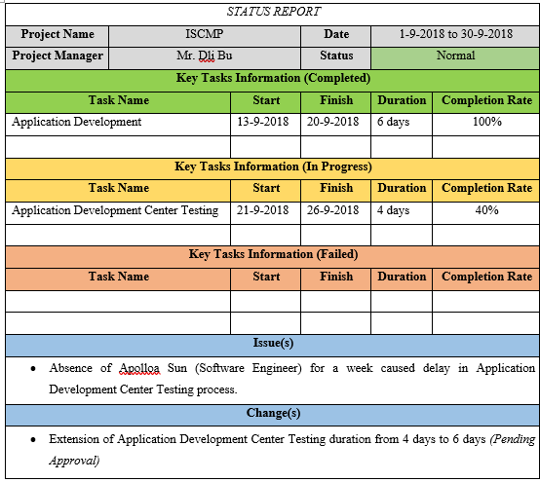

***TABLE 10.3.4: ISCMP Status Report Sample***

1. **Progress Report**

Unlike status report, progress report indicates **what has been accomplished** within the project team, with the amount of time mentioned to determine the period used to finish the tasks. It is usually adapted in cases where milestones are met for the project’s scopes. While not as complicated as status report, important information would be needed to convey about the project’s activities in the **monthly** format as shown, using ISCMP as an example of the case in ***TABLE 10.3.5***:

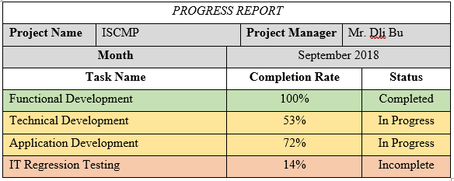

***TABLE 10.3.5: ISCMP Progress Report Sample***

1. **Forecast Report**

Based on the past experiences and trends, forecast would be made to **predict a project’s status and progress** to anticipate how long would it take to complete the project’s milestones. The reference would usually root from the similar projects that have been attempted at the pastimes. In the case of ISCMP scenario as in ***TABLE 10.3.6***, a **monthly** forecast report would be made to anticipate the priority of each tasks that should be given:

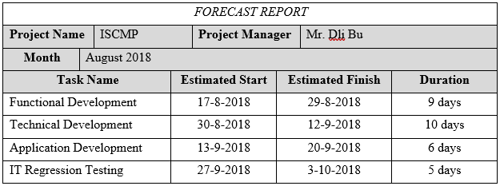***TABLE 10.3.6: ISCMP Forecast Report Sample***

**CONTROL COMMUNICATIONS**

After the communication methods have been implemented, the communication process in the project team would be constantly monitored and controlled to ensure that the requirements from the communications management plan are met.

With reference to the outputs from the planning and managing processes such as the project management plan, project communication system, data of work performance, and organizational process assets, the controlling process of the project team’s communication delivers the **information on work performance**, lists of **change requests**, and **updates** on **project management plan**, **project documents**, and **organizational process assets**. In this process, constant observation and monitoring is necessary to produce these outputs at designated intervals.

**Issue Log**

Issue log is a method often used to **identify the project’s issues** that are either resolved, or still ongoing. In this scenario, it could be used to **track any errors** that occurred in ISCMP, while presenting to the project managers and stakeholders on the project’s status even further (Marchewka, 2014).

While it is just a tracking of the project’s progress, it **contributes in meetings** among members of the ISCMP team and resolves **ISSUE NO. 6** as well. Issue log is, in this case, a list of occurring problems of the project that is required to be solved, and thus serves as a **clear guideline** to the project team staffs to **have immediate and precise understanding on the tasks** in which they need to take priority for. In a way, it contributes to a better alignment of tasks delegation for determining a more approachable Work Breakdown Structure. In short, a **regularly conducted meeting paired with effectively organized issue logs** would resolve the issue of decentralized Work Breakdown Structure.

In a section of Issue Log as shown in ***TABLE 10.3.7***, the issue’s index, with its description, would be mentioned with summary of the issue. Using **ISSUE NO.6** as the core of the issue, it is shown that the issue being the Work Breakdown Structure being done in separate instead of a centralized manner, and not reviewed at top of that.

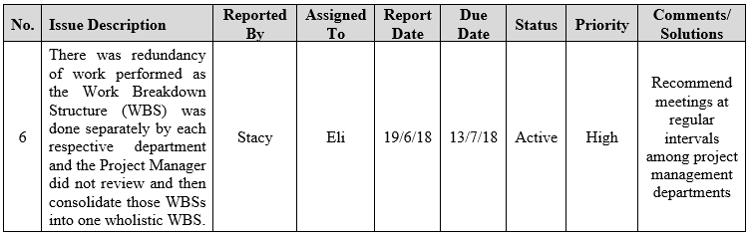***TABLE 10.3.7: Issue No. 6 Section of ISCMP Issue Log Sample***

The individual(s) who states the issue and the ones whom are directed with are mentioned in the Issue Log as well. This is to **ensure the clients related to the issue are properly addressed**. For this issue, the person who reports the issue would be a **representative from the project development team** (e.g. Software Engineers), with the placeholder name of Stacy; while the addressed individual would be the **Project Manager**, whose placeholder name is Eli.

The same concept is applied for the statement of report date and due date, to **indicate the time required to resolve the issue**, although usually by rough estimated for the issue’s manager. The report and due dates in this instance are based on the project’s pre-determined milestones, where the report date is **when the project has received approval** (19/6/18), and the due date being the time when the **project planning has completed** (13/7/18), the time when WBS must be finished and is set as the guideline for project execution.

The issue’s status **informs the clients if the issue has been resolved**, while the priority **shows the issue’s level of importance** compared to other issues, since a typical project would have multiple issues occurring at the same time intervals. The status could be identified in 2 main stages, where it could be already resolved (Closed), or **still ongoing and not resolved yet (Active)**. This issue takes place on the latter stage. The levels of importance, on the other hand, ranks the issues in 3 stages, as in not important (Low), occasionally urgent (Medium), and **immediate emergency (High)**. This issue falls on the ‘High’ category as it must be resolved during the project’s planning phase.

The comments would normally be a **post script on sections required to be aware on the issue**, based on the client’s point of view. However, if resolved, its solutions would be written instead as a reference for solving other issues. In this case, since the issue is not yet resolved, **comments from the client’s side** on recommended actions would be noted down, as in *“recommend meetings at regular intervals among project management departments”.*

**Sample Issue Log**

An example of the issue log applicable in ISCMP is shown in the following table with appropriate issues as samples, as displayed in ***TABLE 10.3.8***:

|  |  |  |  |  |  |  |  |  |
| --- | --- | --- | --- | --- | --- | --- | --- | --- |
| **No.** | **Issue Description** | **Reported By** | **Assigned To** | **Report Date** | **Due Date** | **Status** | **Priority** | **Comments/ Solutions** |
| 1 | The steering committee (which consist of the board of directors, CEO and Senior Managers of the organization) do not recall of being presented the project feasibility study by the Project Sponsor or the Project Manager to them. | Condon | Eli | 10/6/18 | 13/7/18 | Active | High | The Senior Managers are still pending reply on contact info |
| 2 | The project approval was not formally documented. | Isa | Eli | 10/6/18 | 19/6/18 | Closed | High | Hired a new secretary |
| 3 | There is no evidence that a proper project management process was followed. | Shela | Hazel | 13/7/18 | 24/7/18 | Active | Low | Hired a new secretary, but still in training |
| 4 | The PC and server hardware technical specifications were constantly being changed to suit new or added requirements. | Lucie | Barr | 19/6/18 | 24/7/18 | Active | Medium | Barr is currently working on a list of approval for the project’s assets |
| 5 | Requirements keep coming in from users almost daily where the GITS-ADC Team Lead keeps on accepting them without hesitation. | Alvera | Hazel | 13/7/18 | 24/7/18 | Active | Medium | Hazel plans on making a new format on Change Approval Report |
| 6 | There was redundancy of work performed as the Work Breakdown Structure (WBS) was done separately by each respective department and the Project Manager did not review and then consolidate those WBSs into one wholistic WBS. | Stacy | Eli | 19/6/18 | 13/7/18 | Active | High | Recommend meetings at regular intervals among project management departments |
| 7 | Most of the team members have been focusing more on their daily operation support rather than tasks being assigned by the Project Manager or their respective Team Lead. | Abaya | Hazel | 24/7/18 | 20/9/18 | Active | Medium | Centralized WBS is still pending completion |
| 8 | Tasks are performed without prioritizing other dependent tasks | Keen | Hazel | 24/7/18 | 20/9/18 | Active | High | Centralized WBS is still pending completion |
| 9 | IT assets acquisition and spending were through PROC Manager with suppliers without going through a proper tendering process. | Langlois | Eli | 13/7/18 | 24/7/18 | Active | Medium | Hazel suggested approval from Barr for tendering processes |
| 10 | Purchasing of IT assets without a proper tendering process has led to overrun by budget. | Chante | Barr | 13/7/18 | 24/7/18 | Closed | Medium | Complied a proper Resource Cost Breakdown |
| 11 | The testing plan was not developed yet. | Nevilla | Hazel | 20/9/18 | 9/10/18 | Active | Low | Software development process pending approval before testing is verified |
| 12 | There was not even a clear designated sponsor (or sponsors) for the project. | Phan | Eli | 19/6/18 | 24/7/18 | Closed | Medium | Procurements were decided on contract-basis after make-buy analysis |
| 13 | There was no clear project organizational structure to manage the project. | Devon | Eli | 10/6/18 | 13/7/18 | Closed | High | Eli has created a new organizational structure upon arrival |
| 14 | The Project Manager’s authority was constantly overridden by the department head managers. | Tom | Hazel | 10/6/18 | 19/6/18 | Closed | Low | Eli has created a new organizational structure upon arrival |
| 15 | Technical skills were especially lacking in the network and security areas. | Tord | Hazel | 19/6/18 | 20/9/18 | Closed | High | HR promised and hired technical assistants on that field |
| 16 | There were no monitoring reports to review as none were prepared and formally documented. | Edd | Eli | 24/7/18 | 9/10/18 | Active | Low | Template for project reports (Status, Progress, Forecast) remained in progress |
| 17 | The risks associated with the project, although documented, had no detailed action plans and were not categorized in terms of impact or severity. | Matt | Eli | 13/7/18 | 9/10/18 | Active | Medium | The risks were to be announced among Senior Managers in meetings for expert judgements |
| 18 | The hardware and software delivery were still being negotiated with some potential vendors while there were only four (4) months to complete the project. | Djeeta | Barr | 19/6/18 | 13/7/18 | Active | Medium | Hazel and Barr needed to discuss on the cost and asset the project team provides initially |

***TABLE 10.3.8: ISCMP Issue Log Sample***

**CONCLUSION**

While communication among project team does not directly impact the project’s development in technical aspect, it is a lifelong factor that would determine cooperation between individuals where team-based projects would highly value for. With 3 of the issues regarding the factor of communication that occurred in ISCMP, the issues could be resolved by adapting the **communication requirement analysis** to understand the best communication medium for everyone; using **issue log**s as guidelines for discussion while conducting **meetings** among project management staffs on proper work schedule planning; and applying the use of **performance reporting** using uniform templates during project updates to ensure a smooth flow of discussions by having every stakeholder on the same page.

**LESSON LEARNED REPORT**

During the analysis of the issues by applying tools and techniques applicable to the solution of those issues, I have learnt the use of **communication requirement analysis** in the aspect of more effective information delivery to all project management team. The analysis could be carried out in multiple forms involving inspecting elements of communication methods, technologies and models to compile a communications management plan for effective communication method selection. In the meantime, the importance of **meetings** and **issue logs** are proven from its adaption to the completion of an approachable Work Breakdown Structure by setting up department-based meetings in regular time intervals, all in the meantime using issue logs as a guidance for arranging all issue’s and task’s priority and status. As for the application on **performance reporting**, the creations of status report, progress report, and forecast report’s templates have been learnt to provide a clear routine check on all department’s progress while ensuring the project team wouldn’t go sidetracked from the low-priority tasks.